**Question 1**

Global DVD is a DVD rental store. Currently they keep a record of their members and the DVD loans on paper. An example is below. They would like to store their information in an electronic form through a database.

|  |  |  |  |
| --- | --- | --- | --- |
| **Member No.** | **Given name** | **Family Name** | **Mobile No.** |
| 1012 | Ali | Abdulla | 33521025 |
| 1034 | Faisal | Swar | 30021525 |
| 1056 | Salman | Rajab | 31122101 |
| 1097 | Zahra | Jaafar | 33665230 |

|  |  |  |  |  |  |  |
| --- | --- | --- | --- | --- | --- | --- |
| **DVD code** | **Title** | **Cost** | **Date Out** | **Date Due** | **Member No.** | **Name** |
| 002 | Finding Nemo | 2BD | 11/01/10 | 13/01/10 | 1034 | Faisal Swar |
| 003 | Duplicity | 2BD | 18/01/10 | 20/01/10 | 1056 | Salman Rajab |
|  |  |  | 21/01/10 |  | 1012 | Ali Abdulla |
| 008 | Shrek | 1BD | 15/01/10 | 17/01/10 | 1097 | Zahra Jaafar |
| 011 | Fast and Furious | 2BD | 05/01/10 | 07/01/10 | 1012 | Ali Abdulla |
|  |  |  | 10/01/10 | 12/01/10 | 1056 | Salman Rajab |
| 014 | Open Range | 1BD | 22/01/10 | 24/01/10 | 1097 | Zahra Jaafar |
| 015 | Shawshank Redemption | 3BD | 28/01/10 | 30/01/10 | 1034 | Faisal Swar |

1. Complete the normalisation of the loan details by producing entities in third normal form (3NF). You should indicate the primary and foreign keys of each entity.
2. Construct an entity-relationship to represent the 3NF model.
3. Model the normalised database using Enterprise Architect.

**Question 2**

Below is a Project Management Report, which describes projects being worked upon by various employees.

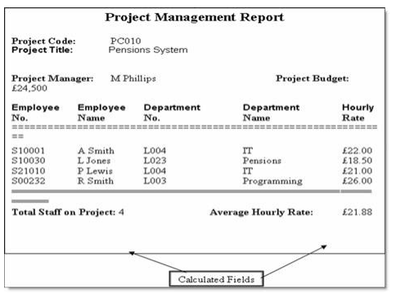

This report needs to be normalised

1. Complete the normalisation of the project management report details by producing entities in third normal form (3NF). You should indicate the primary and foreign keys of each entity.
2. Construct an entity-relationship to represent the 3NF model.
3. Model the normalised database using Enterprise Architect.